EXCEL DATA ANALYTICS MINI PROJECT REPORT
Data Cleaning • Data Model • Relationships • PivotTable Analysis
Excel Data Analytics Mini Project | Prepared for Assignment Submission
1. Project Objective
The objective of this mini project was to transform raw e-commerce sales data into a cleaner, analysis-ready Excel workbook and use Excel analytical features to generate meaningful business insights. The project focuses on data cleaning, preparing dimension and fact tables, creating relationships, using formulas, and building PivotTable-based analysis.
2. Dataset Overview
The workbook follows a simple dimensional data-model structure consisting of customer, product, store, and sales transaction data. The raw sheets were retained and separate cleaned sheets were prepared for analysis.
Data Area | Raw Records | Cleaned Records Used | Purpose
Customer Dimension | 500 | 496 | Customer profile and loyalty analysis
Product Dimension | 100 | 100 | Product, category, cost and stock analysis
Store Dimension | 20 | 20 | Store, region and store-type analysis
Sales Fact | 2,000 | 2,000 | Transaction-level revenue and sales analysis

3. Data Cleaning Performed
The raw data contained several Missing data and Inconsistent Data that needed to be addressed before analysis. The cleaned sheets were separated from the raw sheets so that the original source data remained available for reference.

Table | Issues Observed in Raw Data | Cleaning / Preparation
Customer | Missing loyalty-level values; inconsistent name capitalization/spacing | Incomplete customer records were excluded from the cleaned customer table and names were standardized.
Product | Missing Cost and Stock values; inconsistent product ID formatting | Product records were standardized and stock/cost fields were prepared for analysis.
Store | Store master data used as the reference table | Store fields were retained in a consistent structure for relationship and analysis purposes.
Sales | Missing Quantity, Unit Price, Discount and Total Amount values | Sales records were prepared as the transaction fact table; derived fields were added for analysis.

Customer Table had inconsistent name capitalization/spacing Incomplete customer records were excluded from the cleaned customer table and names were standardized.

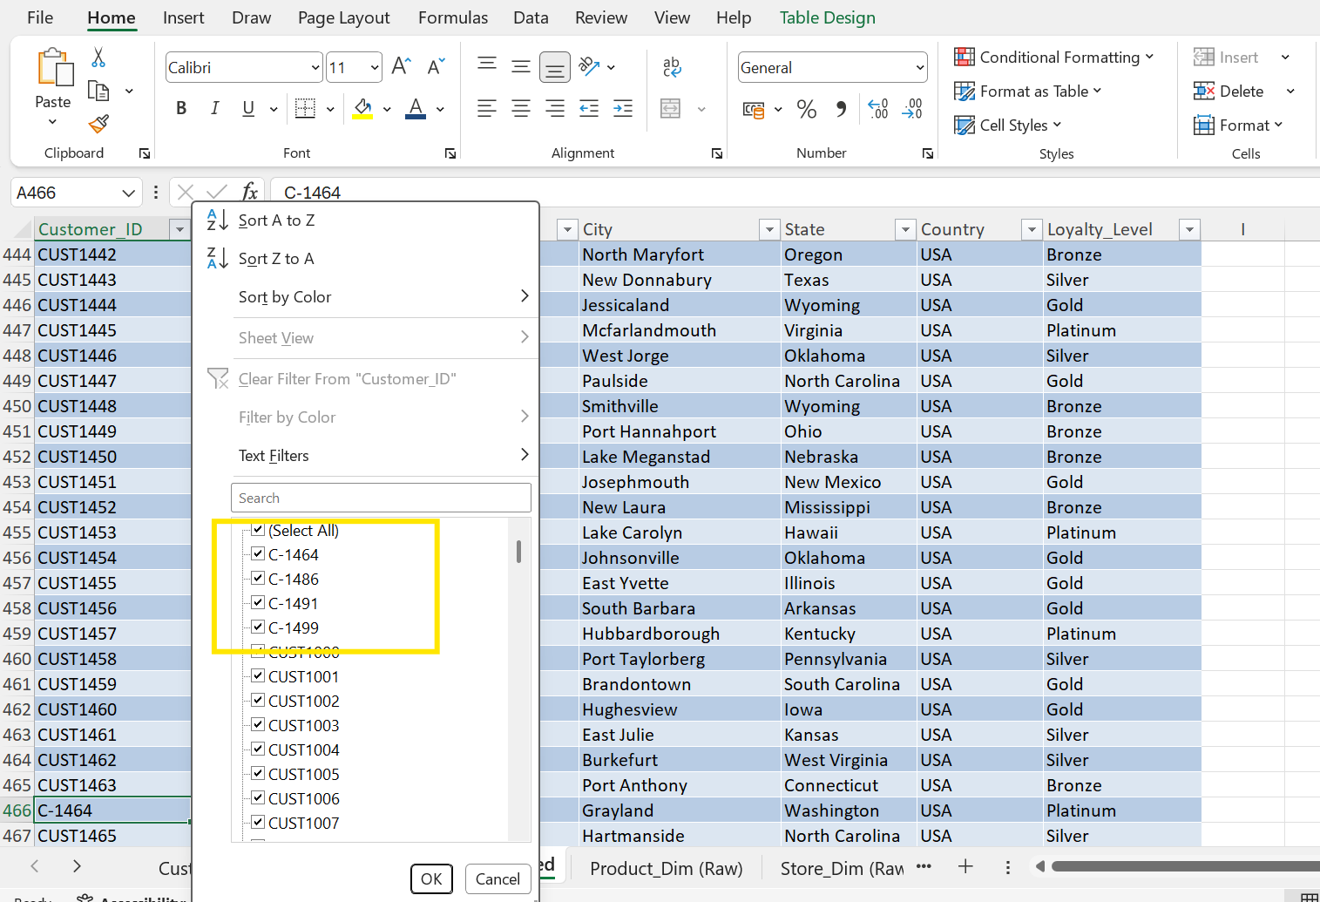

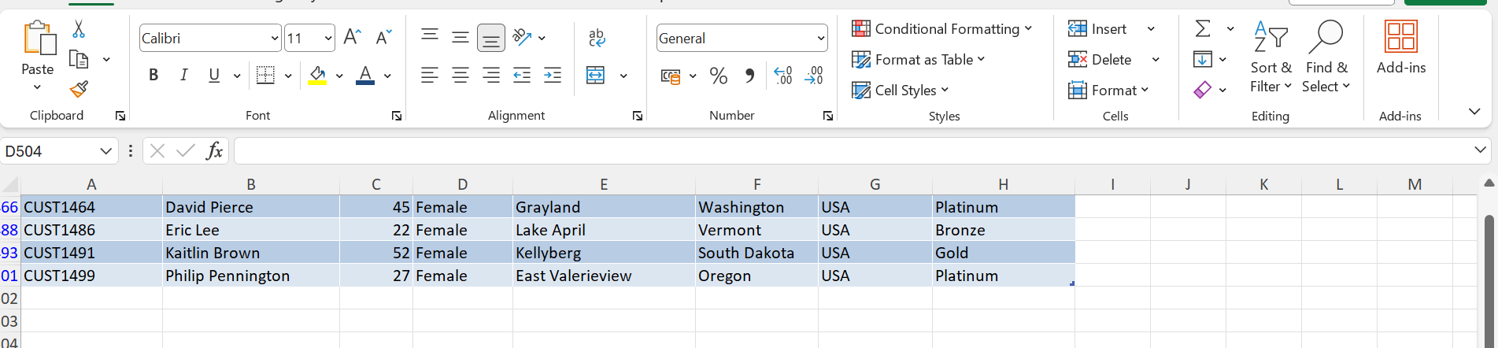

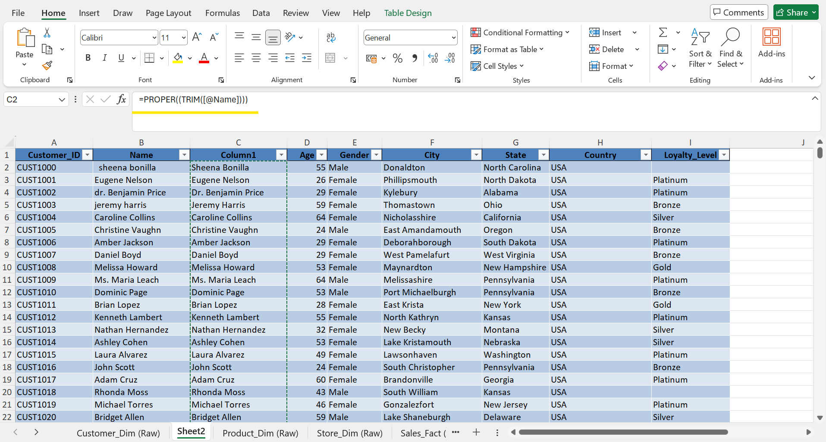
Country column had Inconsistent Data Standardized by replacing United states of America with USA.
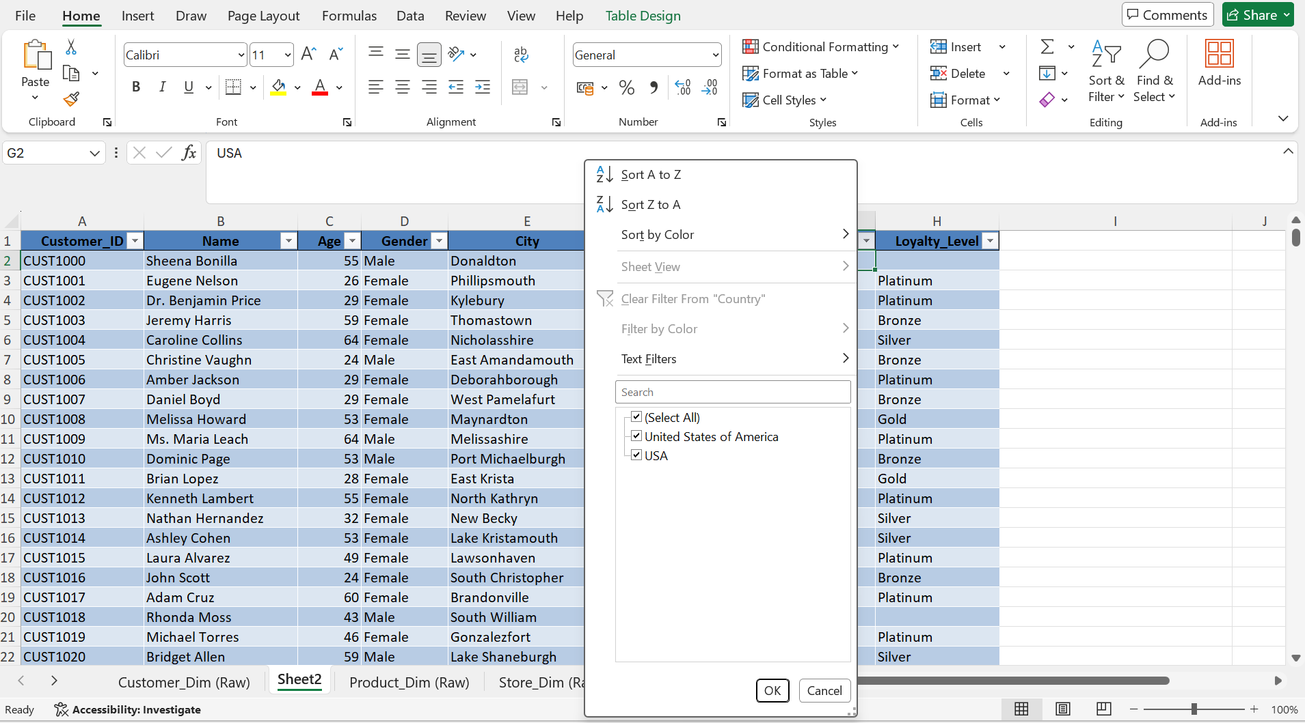
Missing loyalty-level values – we see 4 out of 500 customer data had no Loyalty value updated, since removing 4 out of 500 data will not affect hence removed the customer data which had no loyalty value.

- Product Table had Missing Cost and Stock values; inconsistent product ID formatting
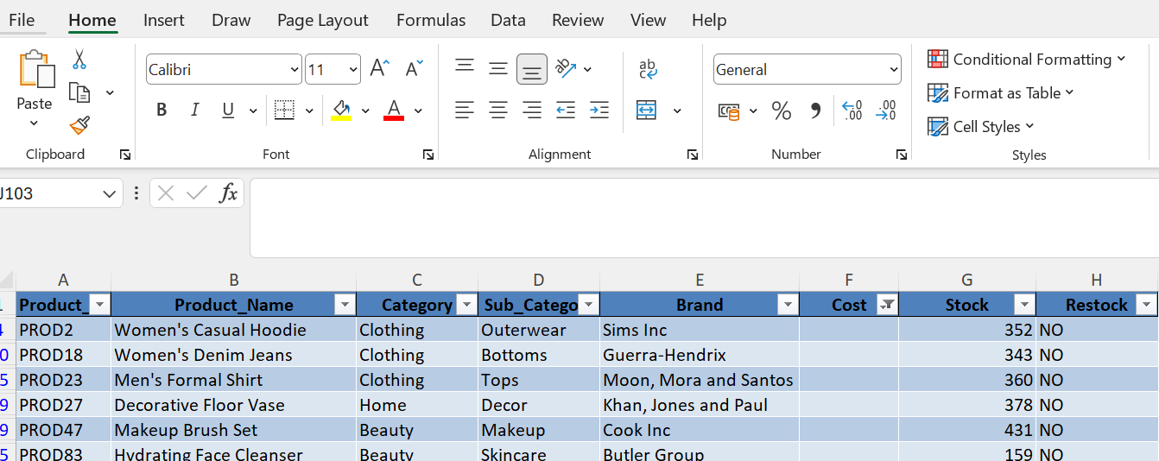

Missing Cost and Stock values; inconsistent product ID formatting
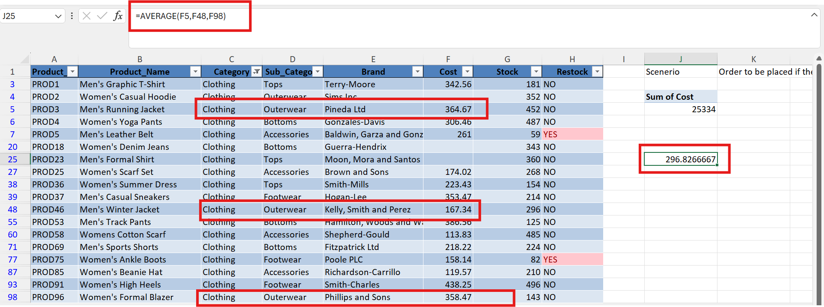

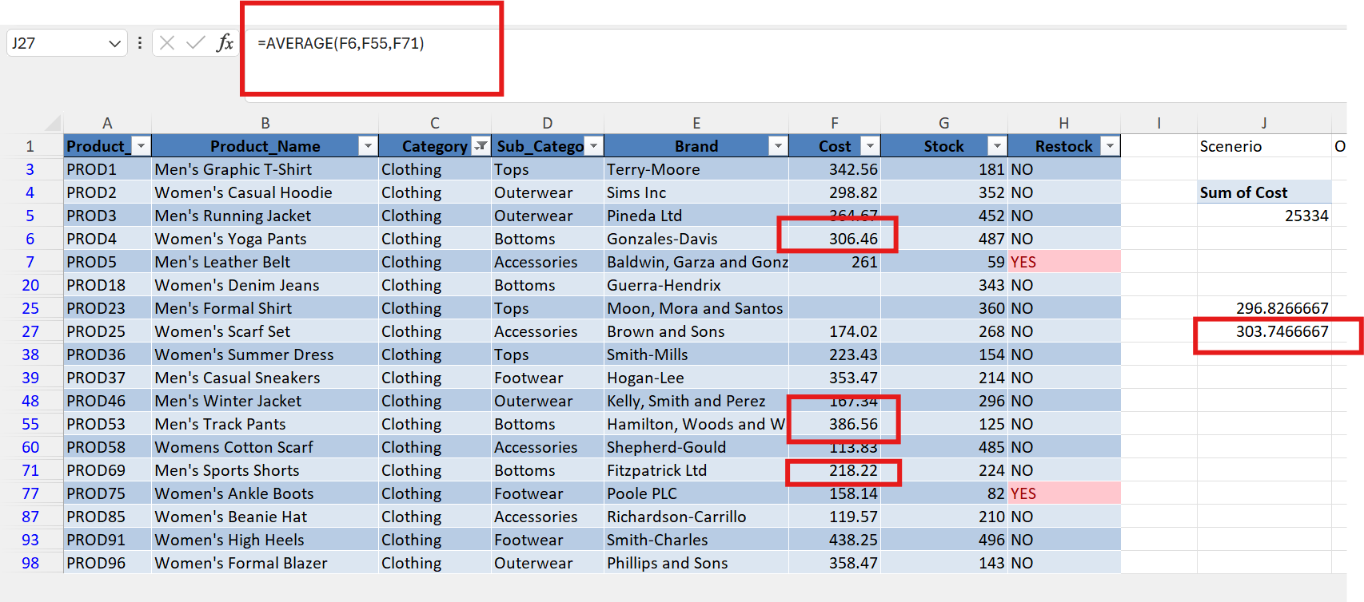

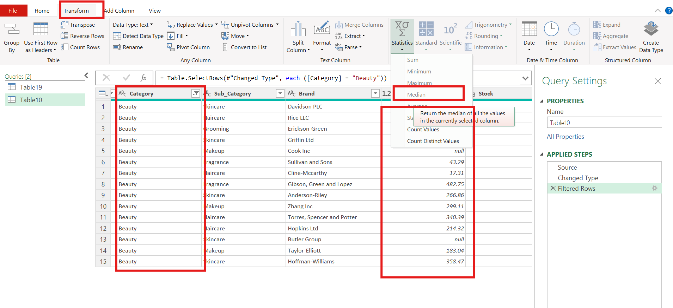

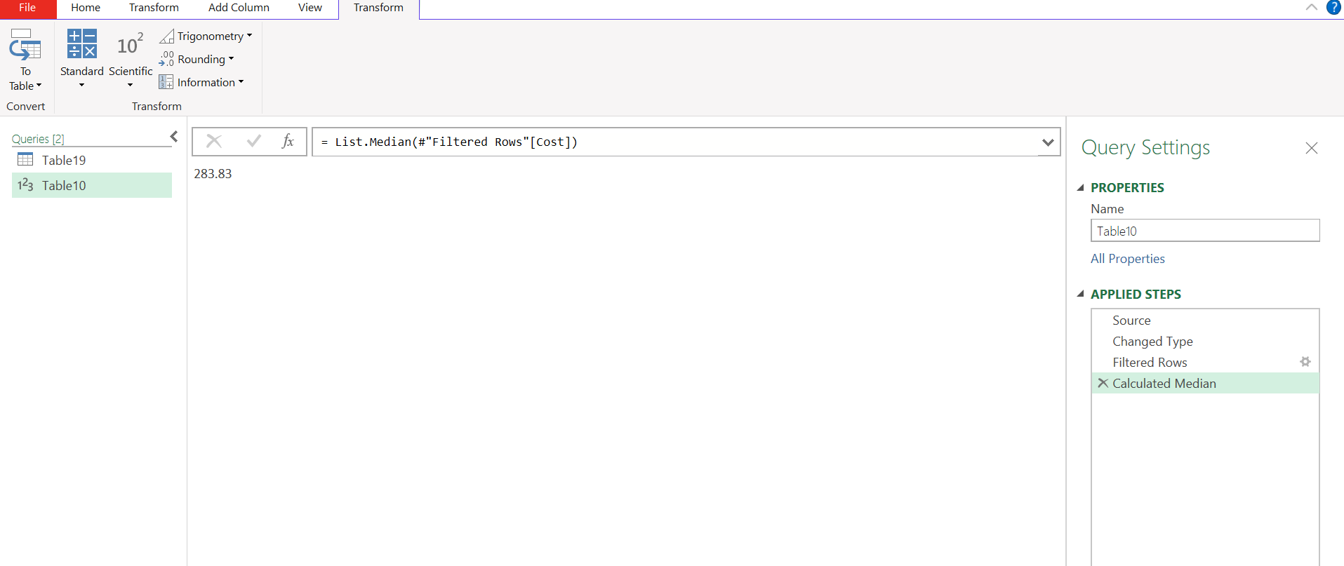
Performed Median function on Stock column data to fill the missing data because the data has outlier.
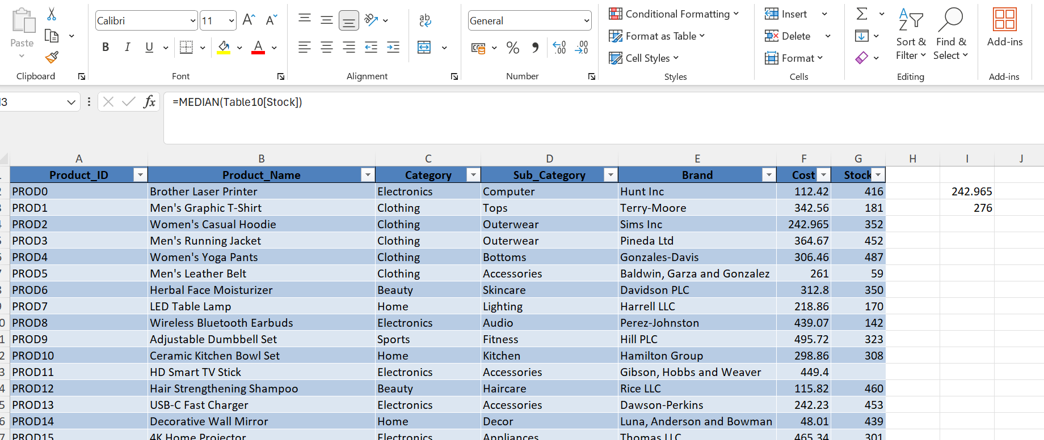

Sales Table has Missing Quantity, Unit Price, Discount and Total Amount values

Performed a function Unitprice-(discount*Unitprice) and then multiplying with respective quantity to fill the missing total amount.
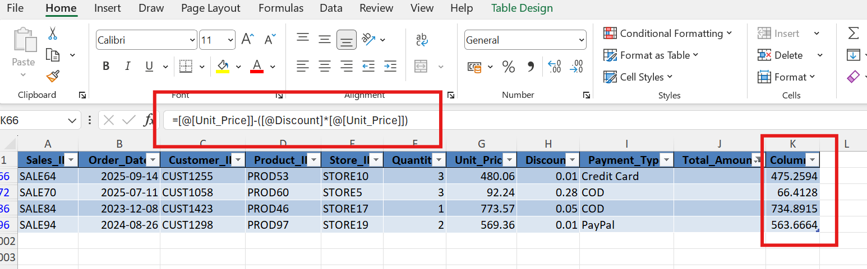
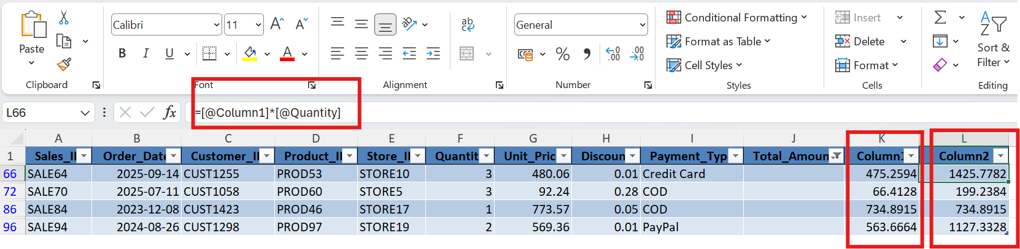

Performed below functions to find the discount
Step 1 - Original Price = (Unitprice*Quantity)

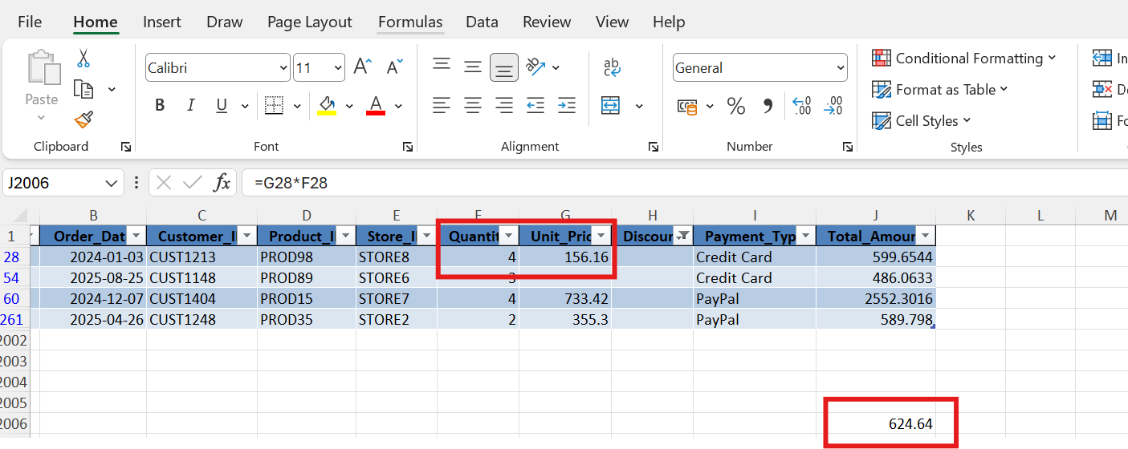
Step 2 – Difference = Original Price – Total Amount
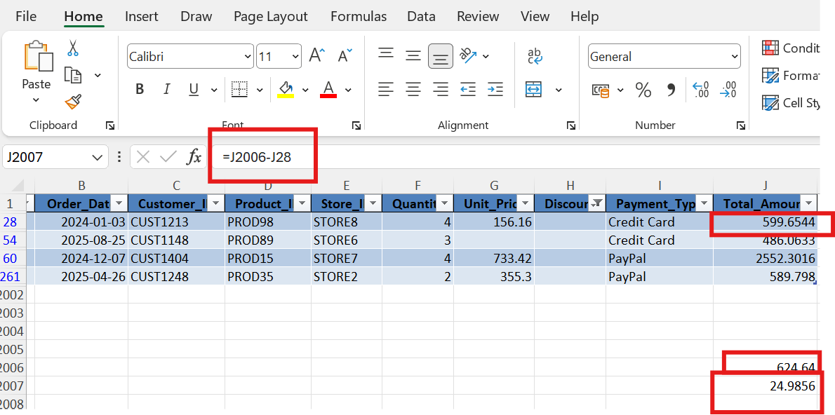
Step3 – Discount = Difference/Original Price
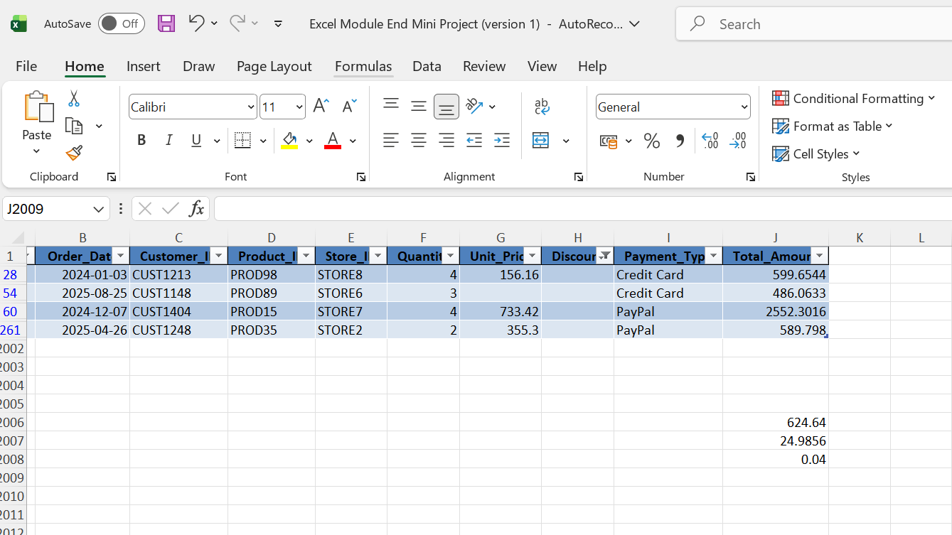

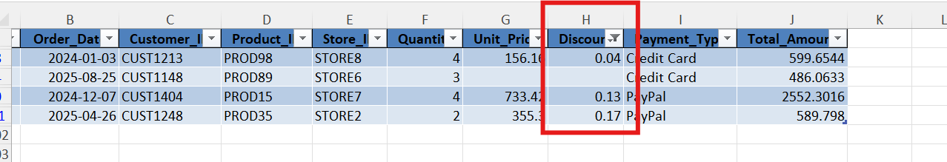
One of the Raw has not got both Discount and also the Unit Price , found the unit price by performing Total Amount/Unit , considered the discount to be ”0”
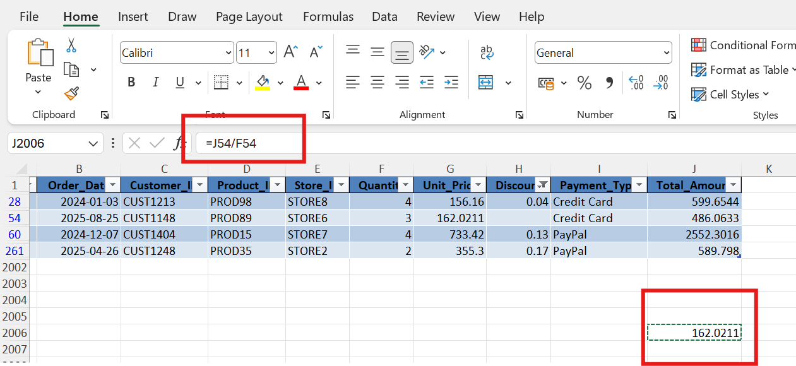

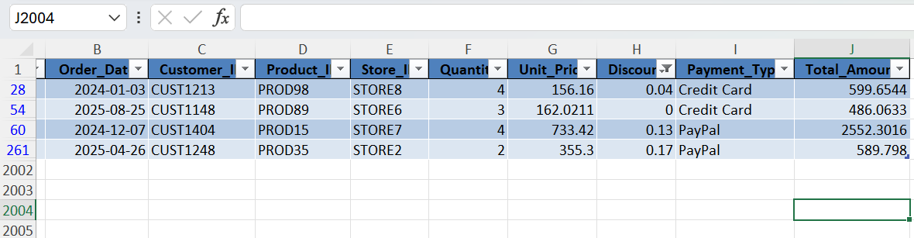

Performed Round off on Unit Price, Discount and Total amount column
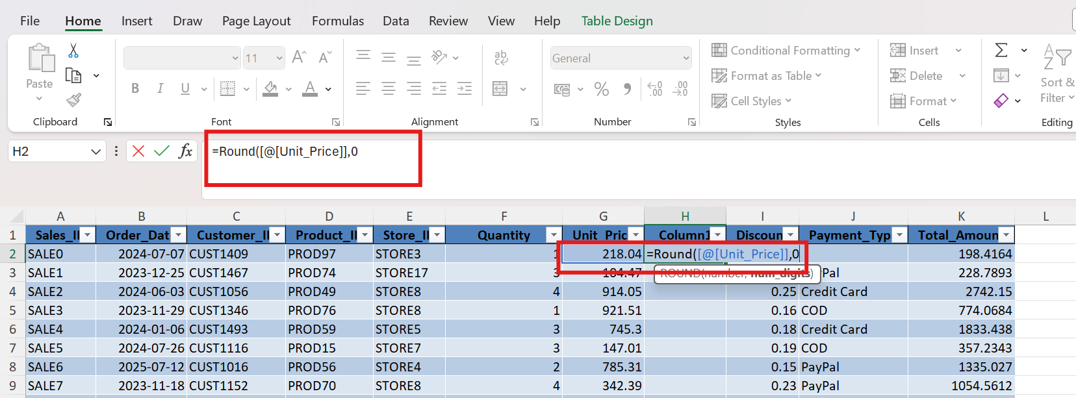

Performed Average function on cost based on Category (Clothing(Outerwear), Clothing(Bottom),Clothing(Tops),,

Performed Median on Stock to fill the missing Stoew

Applied If Function to return as “Offer” for products with discounts > 0.21 else “No offer”
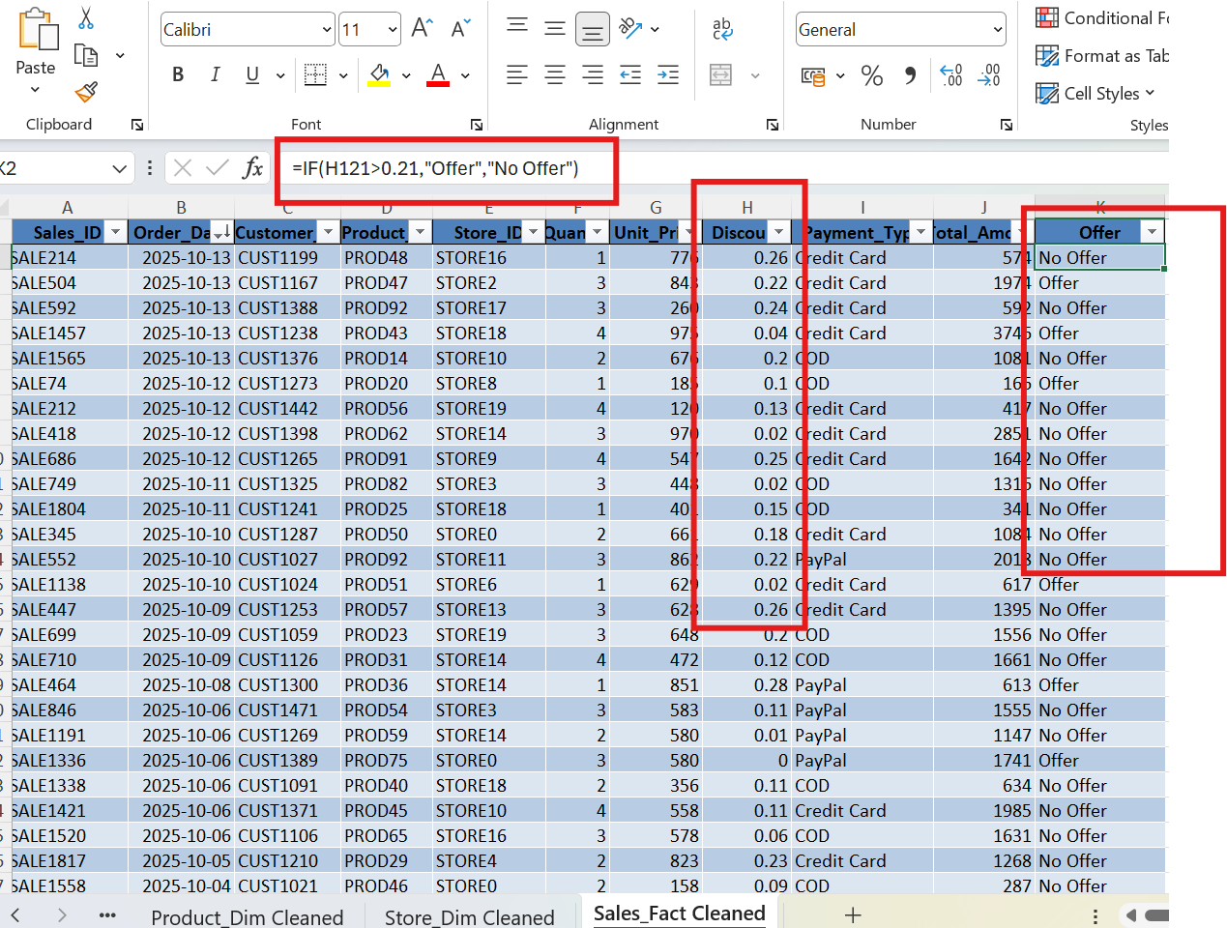

Product Stock Analysis - An IF formula was used to flag products requiring restocking when stock was 100 or below.

Created a Restock Column with If condition to return “Yes” for Stock is <100 else return “No” and also Applied Conditional Formatting to the Restock column from Home-Conditional Formatting

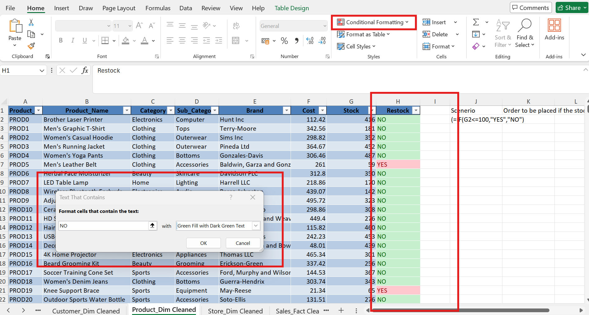

Performed Vlookup to sort and return Customer Name and City for the provided CustomerID
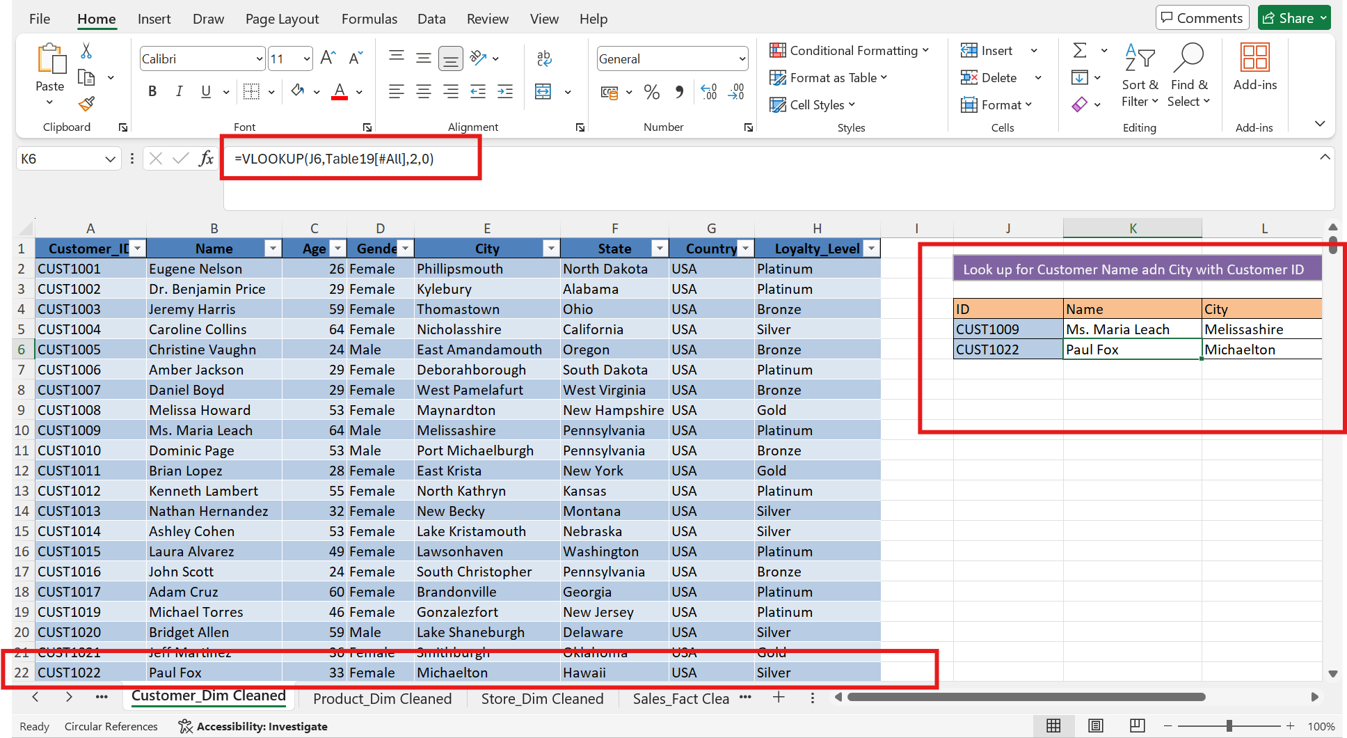

Performed XLOOKUP to sort and return the Order Date and StoreID for the known particular CustomerID
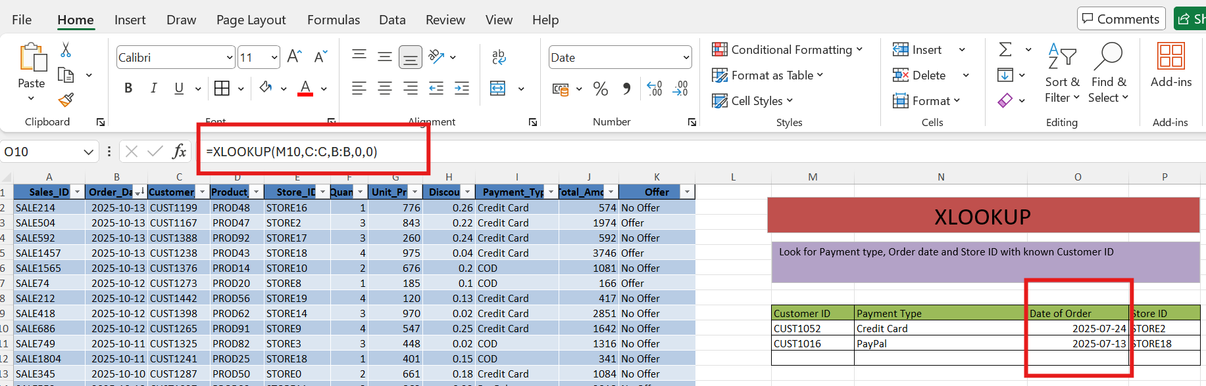
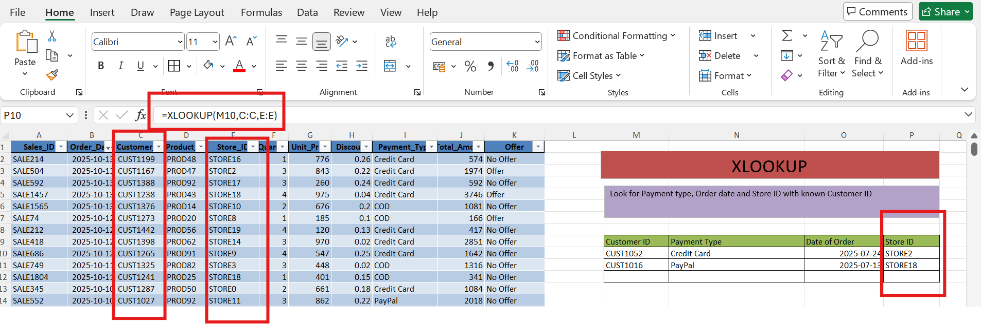
Analysis | Technique / Purpose
Sales Metrics | SUM, MIN and MAX were used to calculate total revenue and price ranges.
Payment Analysis | SUMIFS was used to calculate revenue by payment type.

Total Revenue =SUM(J:J)
Total Revenue by COD, PayPal, Credit Card Payment
Max and Min Unit price - =MIN(G:G) and =MAX(G:G)
Count the number of Sales done by particular Store- =COUNTIFS(E:E,"store11"
Daily Sales Analysis - COUNTIF and SUM-based calculations were used to review sales activity by date. (=COUNTIF(B:B,"=2025-10-13") (=SUMIF(B:B,$M33,J:J)
Store Sales Count - COUNTIFS was used to count transactions for selected stores.

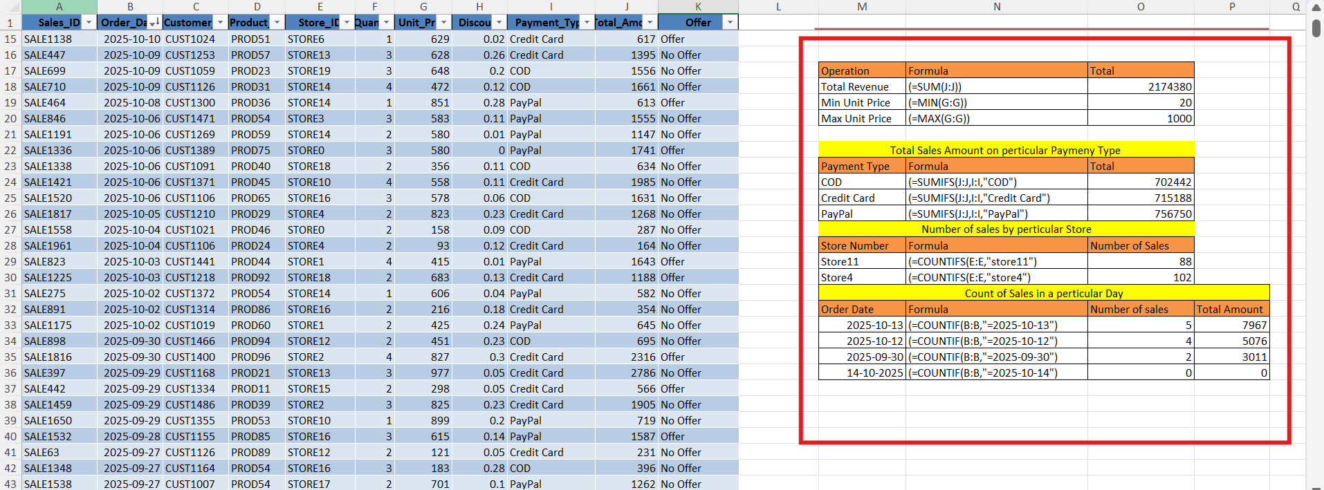
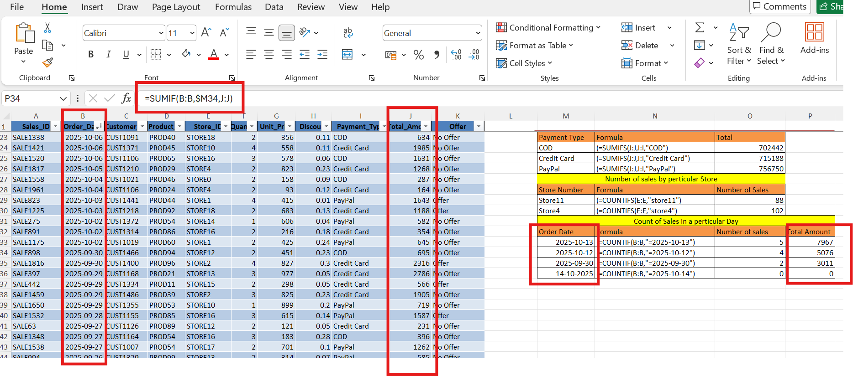
5. Analysis and Excel Techniques Used
Analysis | Technique / Purpose
Customer Loyalty Analysis | A PivotTable was used to count customers by Loyalty Level and Gender.
Monthly Revenue Analysis | Revenue was summarized by month and category/region using a PivotTable.
Category Cost Analysis | A PivotTable summarized product cost by category and sub-category.
Offer Classification | An IF formula classified transactions based on the discount threshold.

Created Pivot in the existing workbook (Product_Dim)
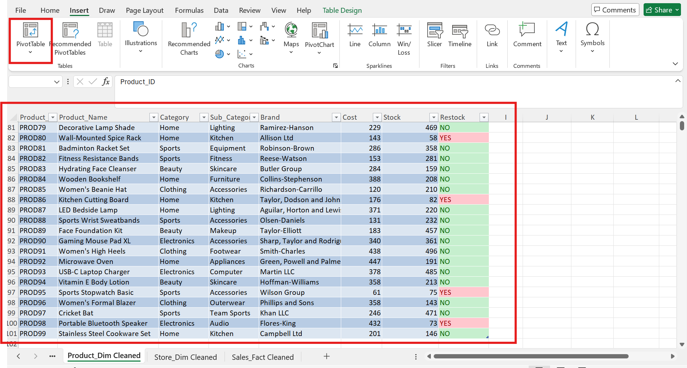

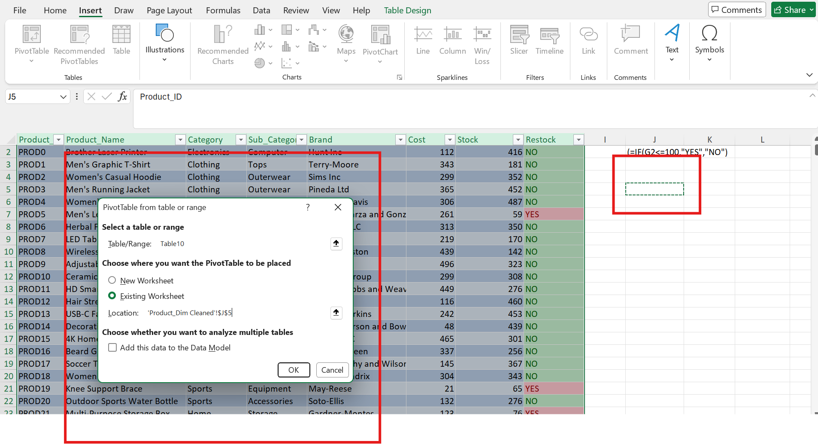

Pivot table showing Total Cost of products based on category and sub-category,

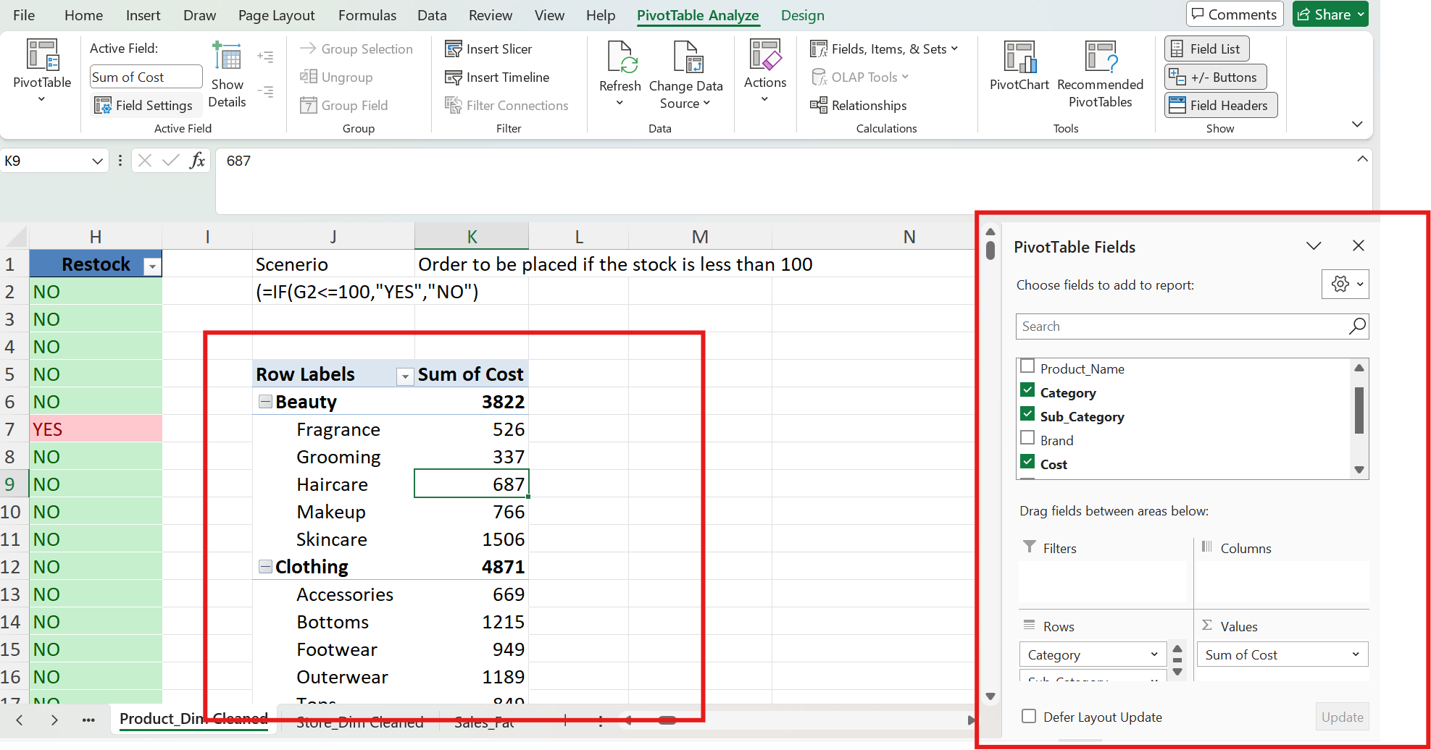
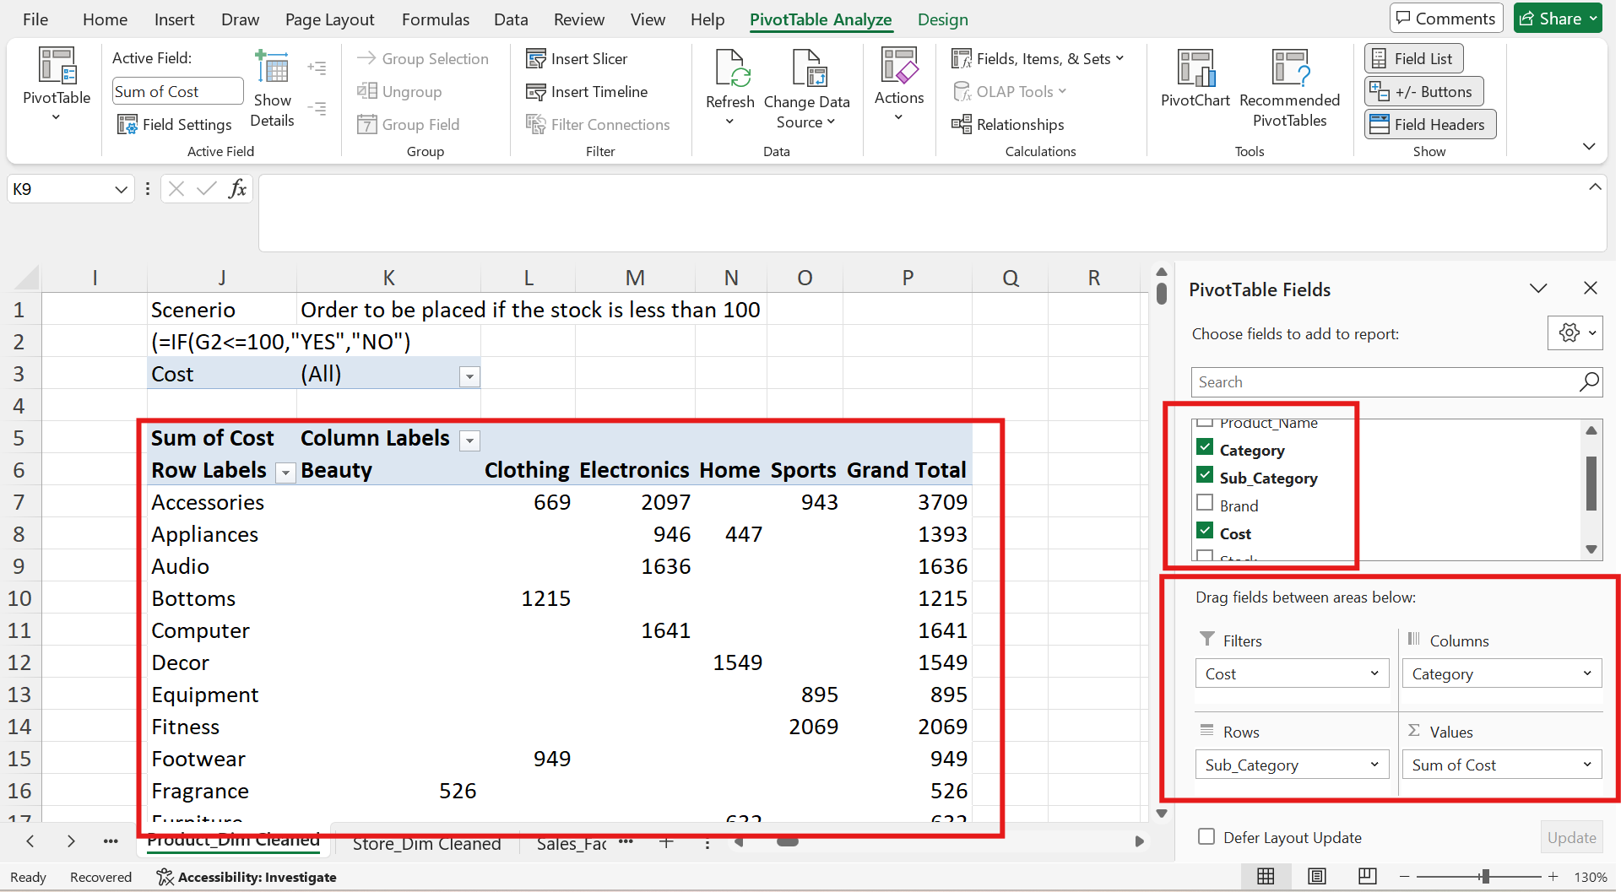

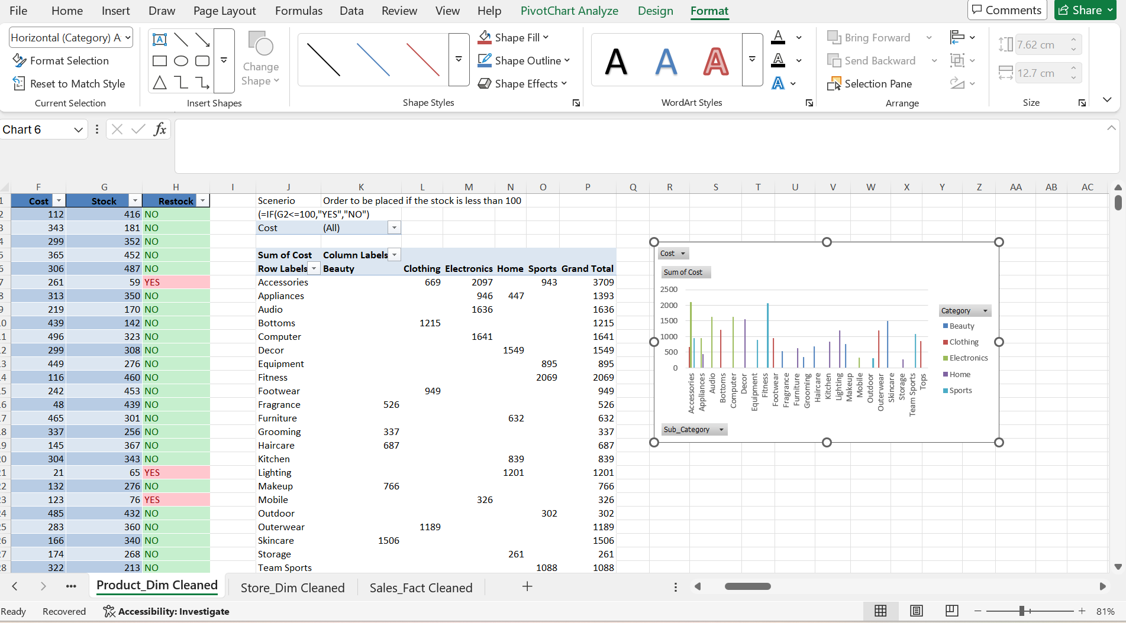

Created Pivot chart for the pivot table for the column showing the cost of products
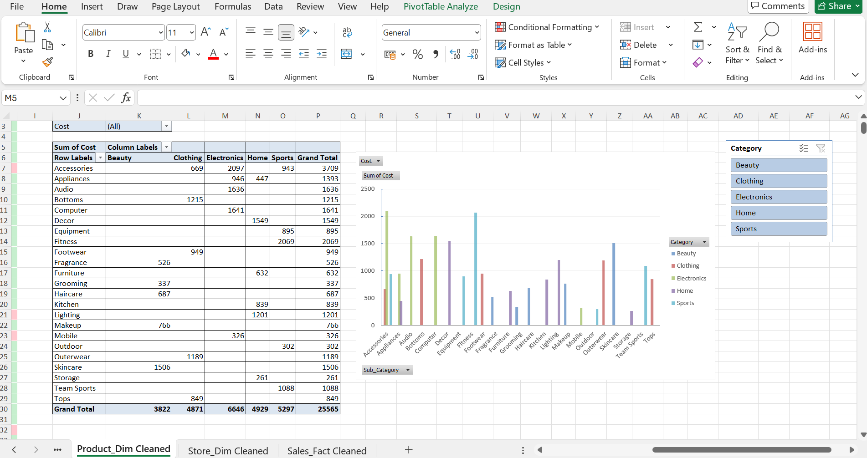
Created a Pivot Chart
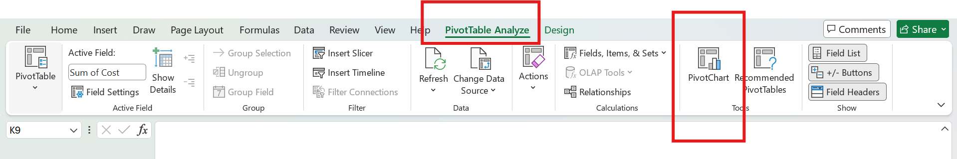

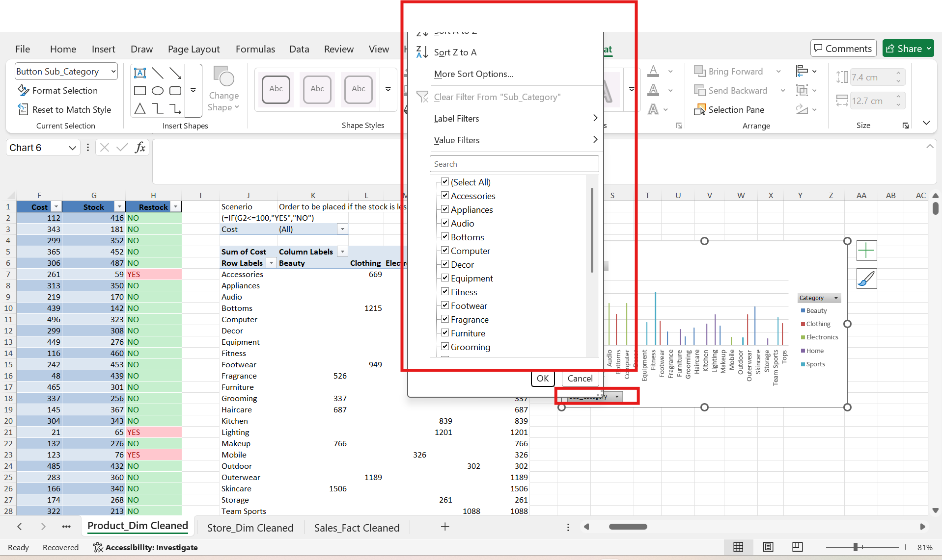

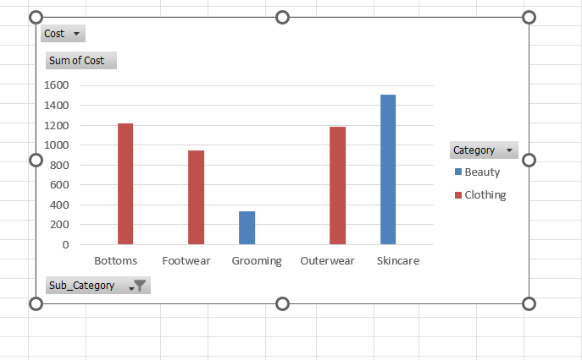

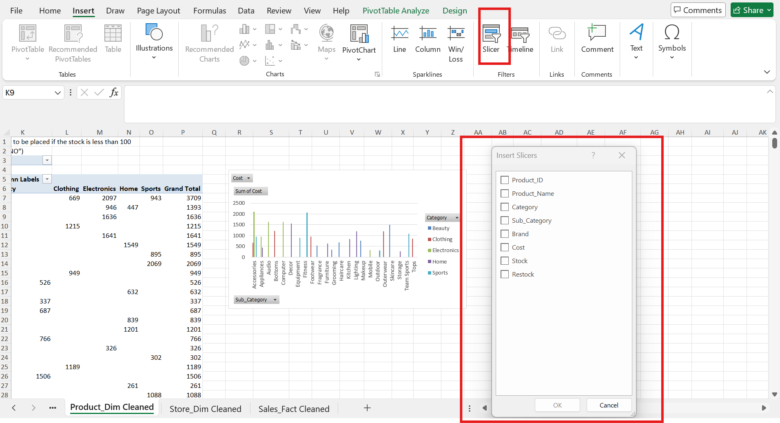

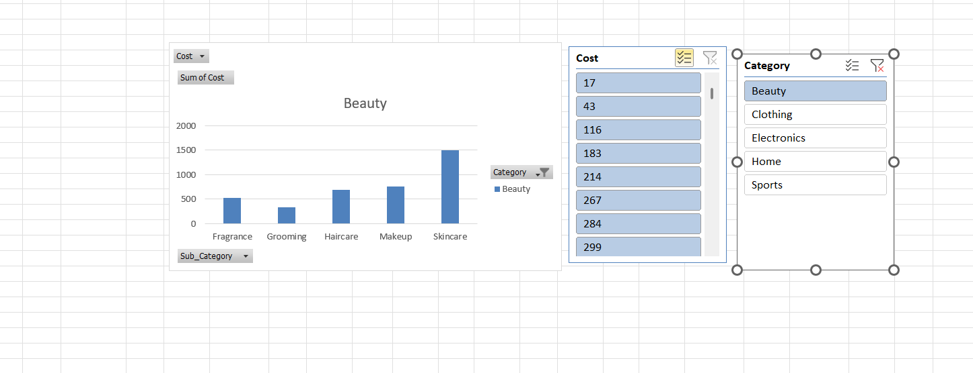

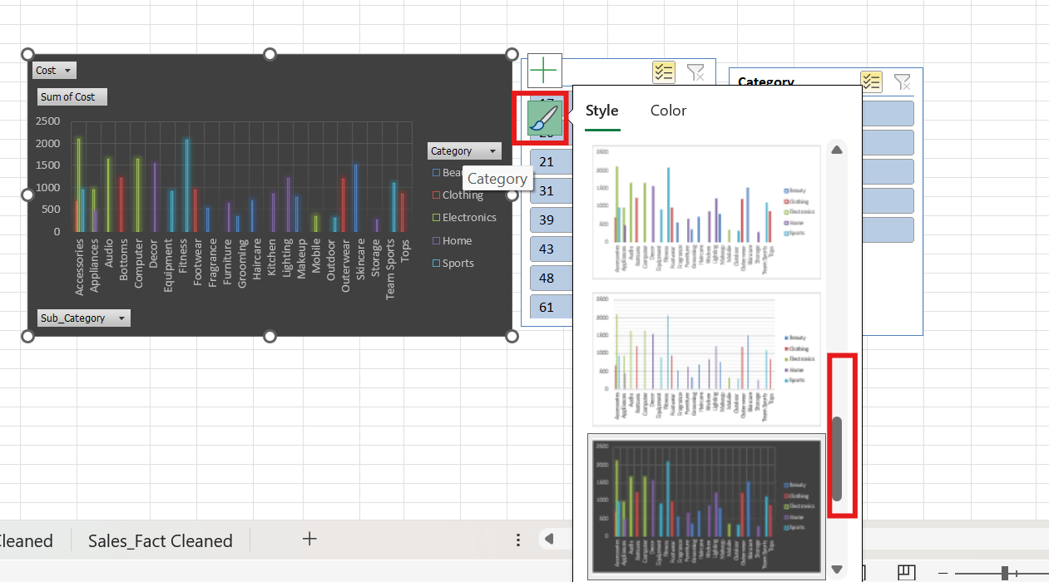
A PivotTable was used to count customers by Loyalty Level and Gender.

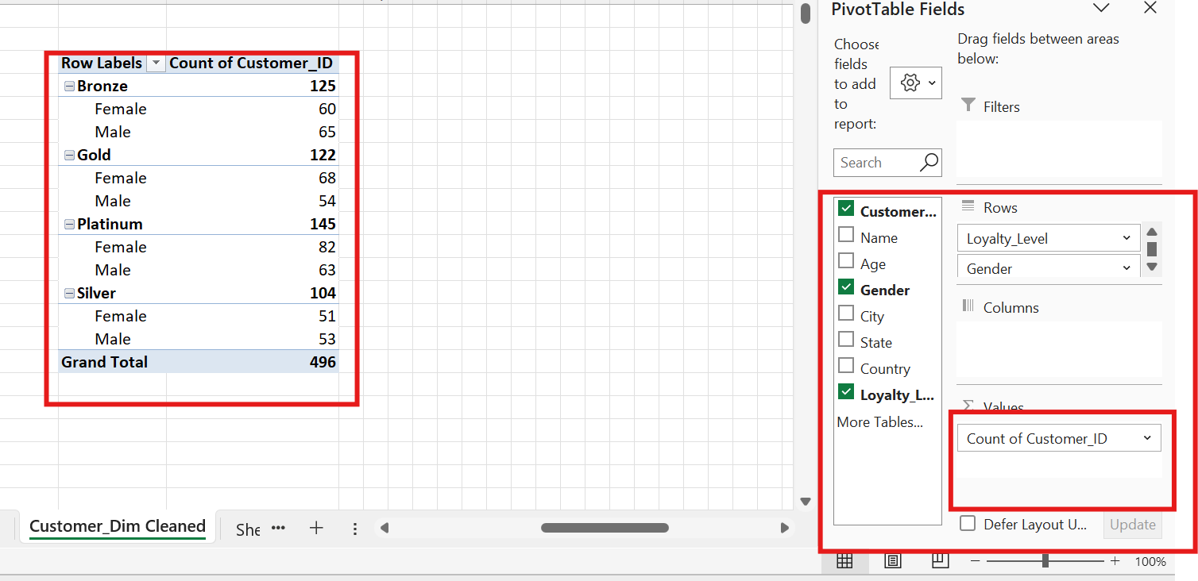

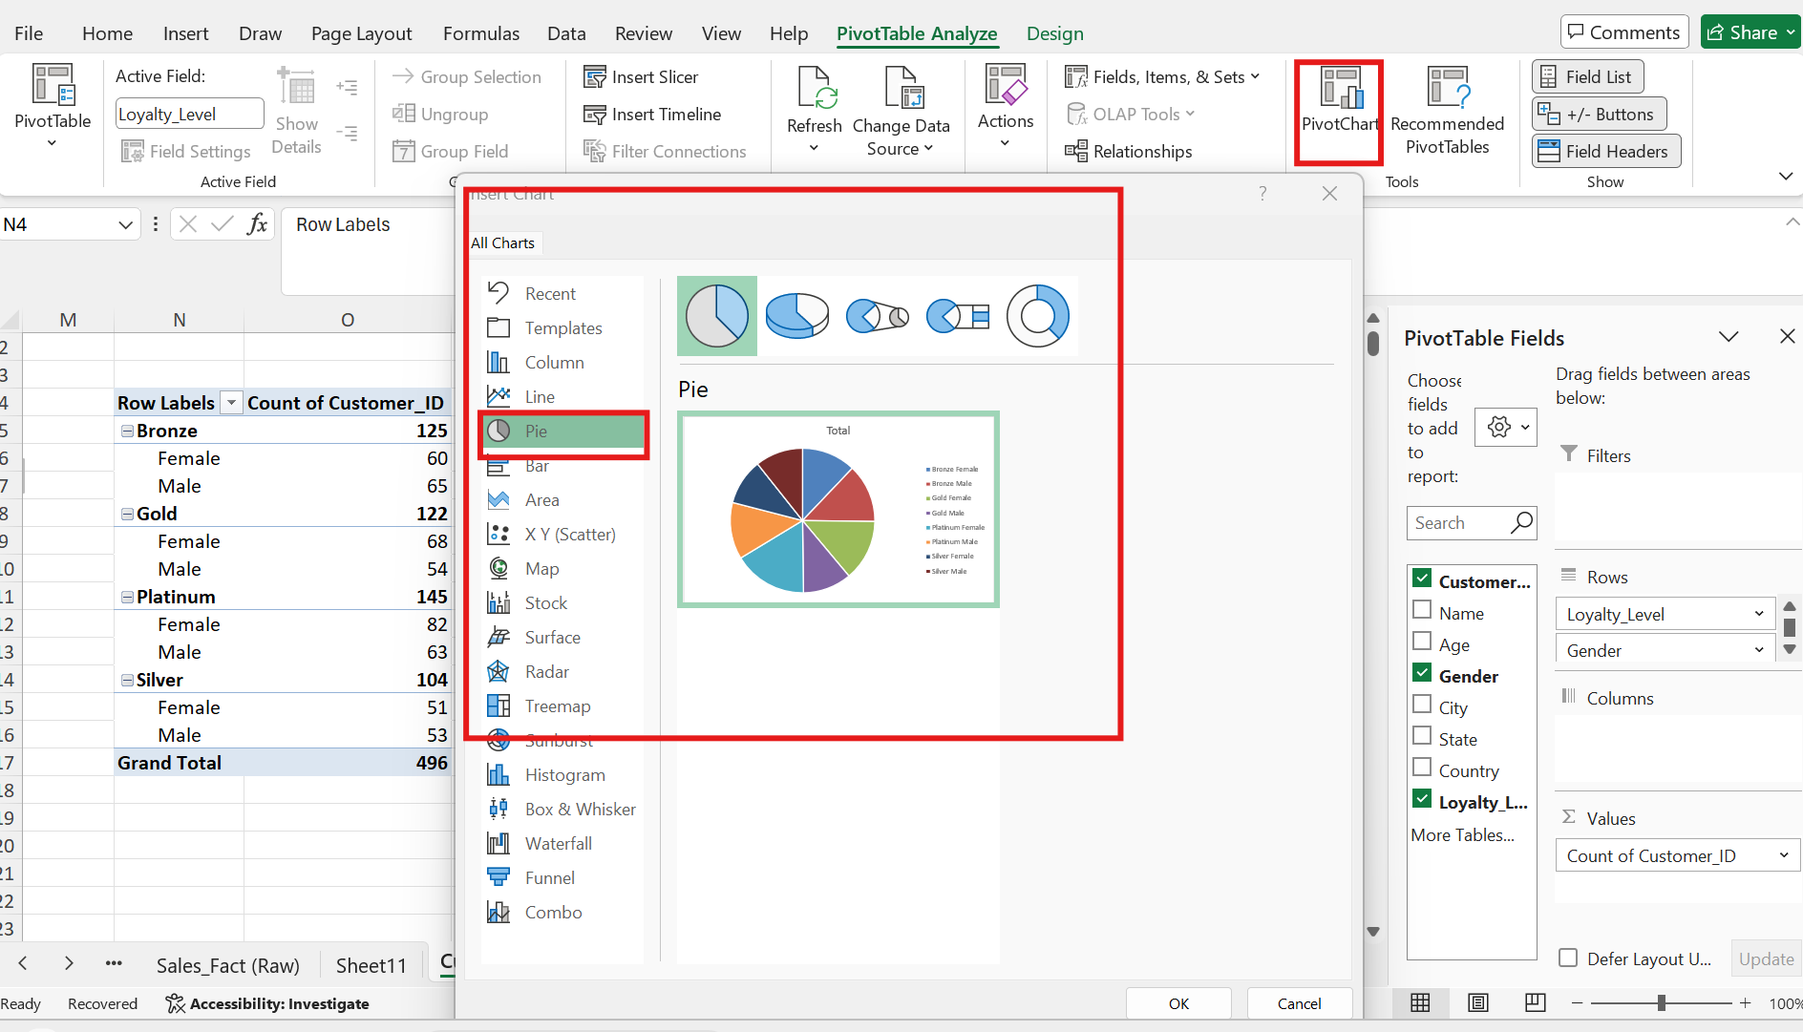

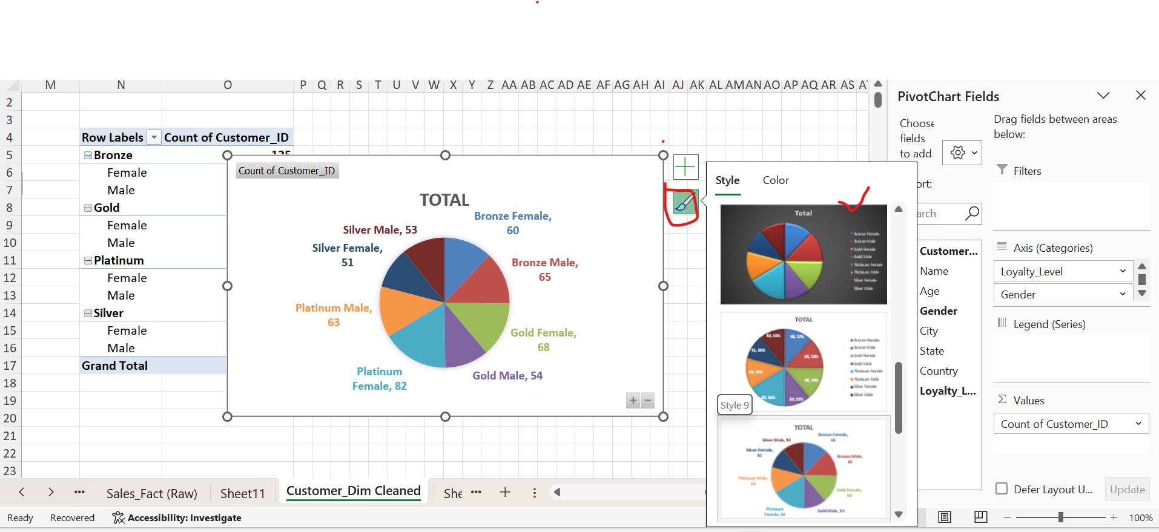

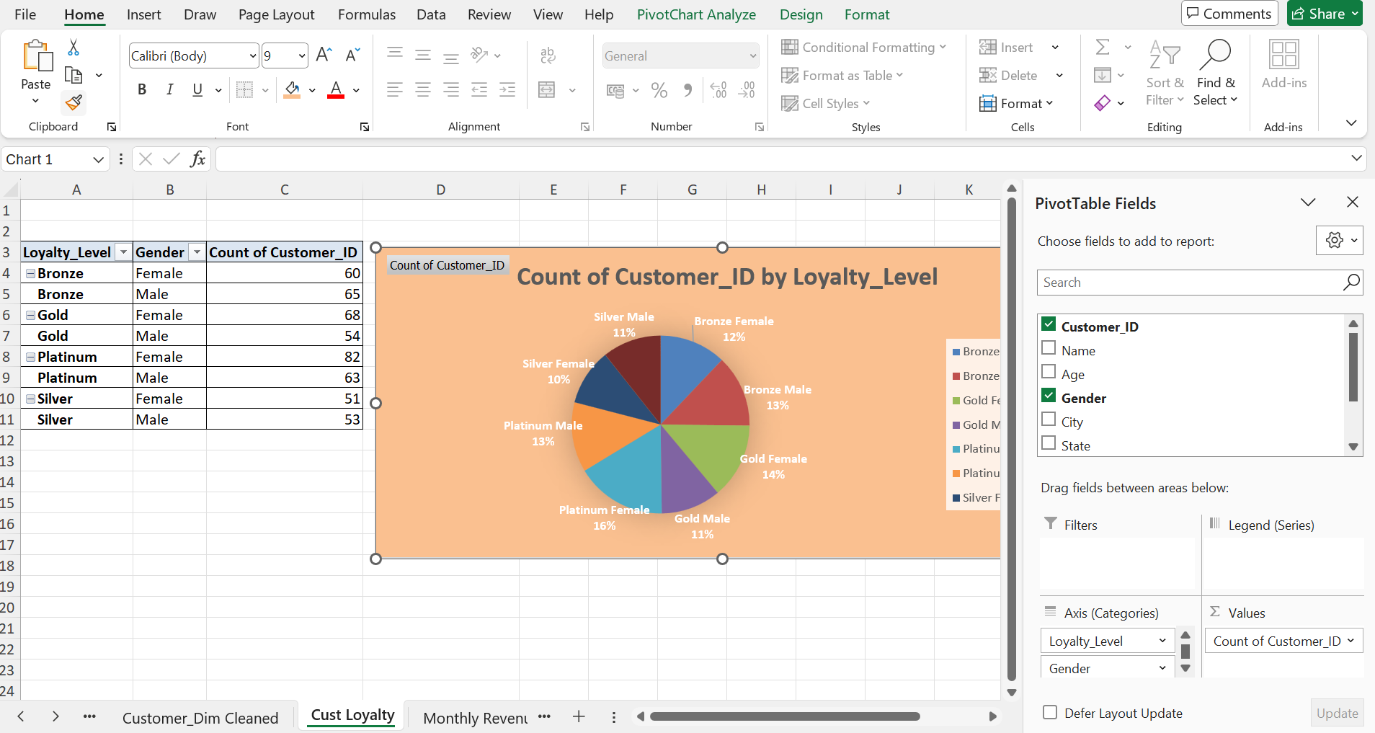

- Created a pivot table to Store Table to show the region wise stores

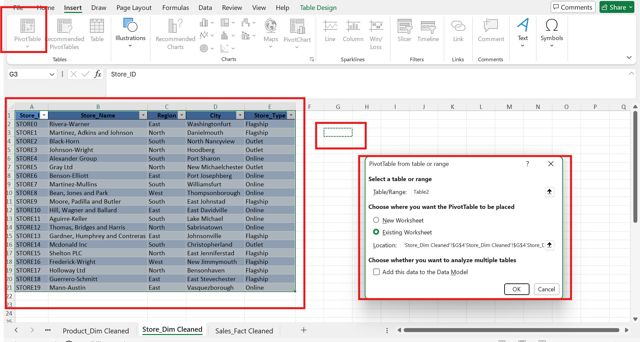

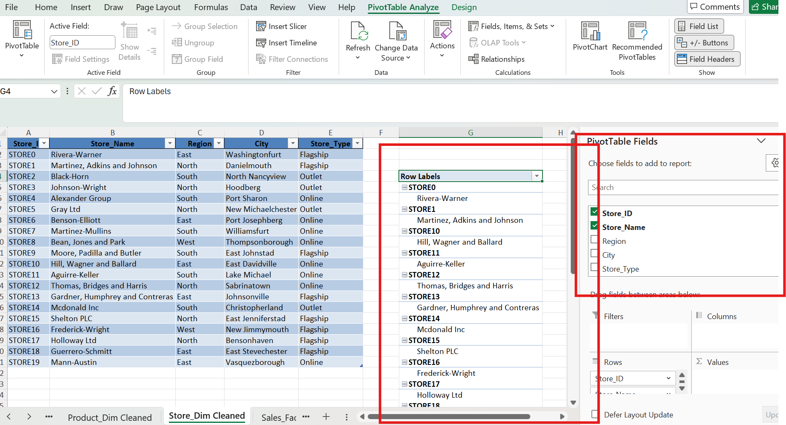

- Created Relationship between tables

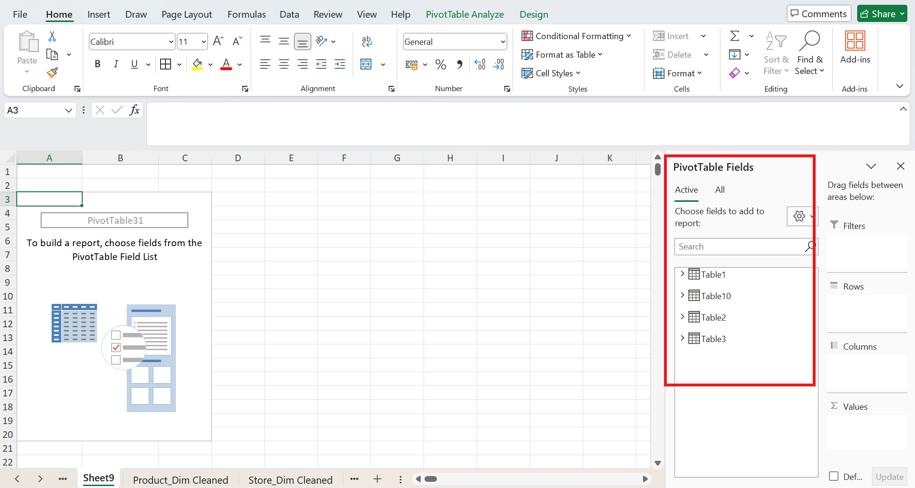

- Created a relationship to find the total revenue based on Order date (Quarter) region category subcategory
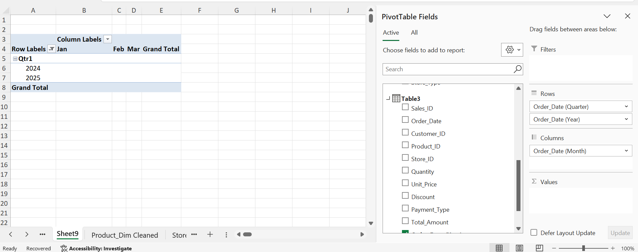


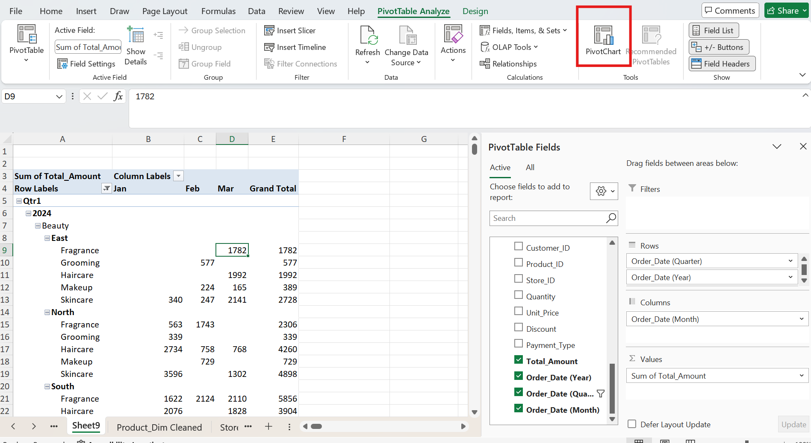

- Created a supportive Pivot chart on Order date (Quarter) region category subcategory

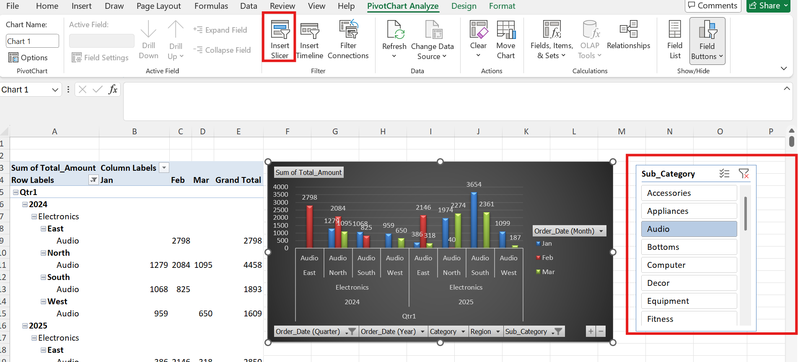

- Created a Pivot for analysing month-over-month revenue growth by store and category.

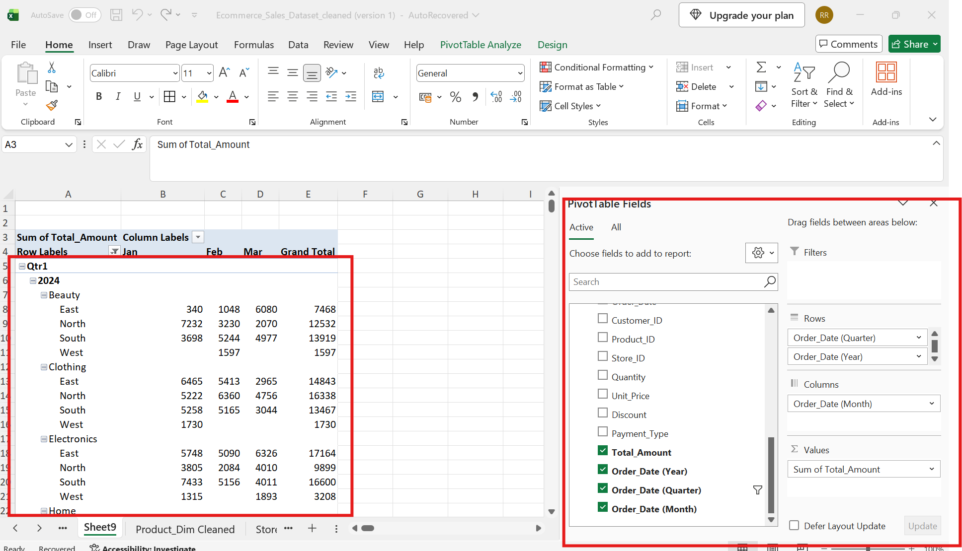

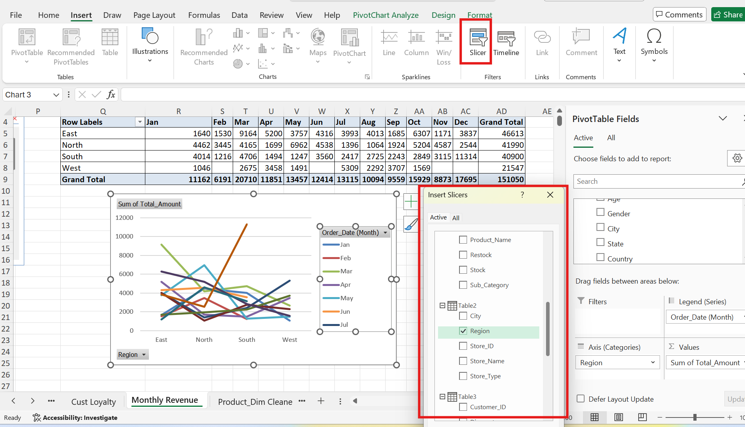

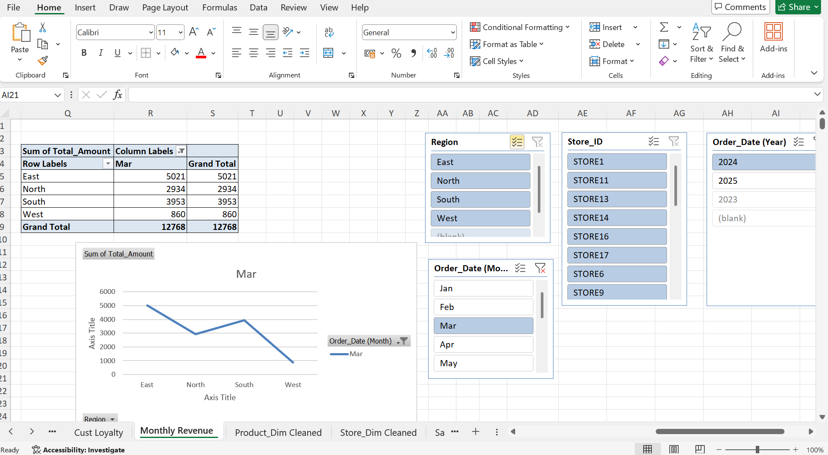

- Created a Pivot table and applied conditional formatting to show Top 3 and Bottom 3 stores generating Revenue.
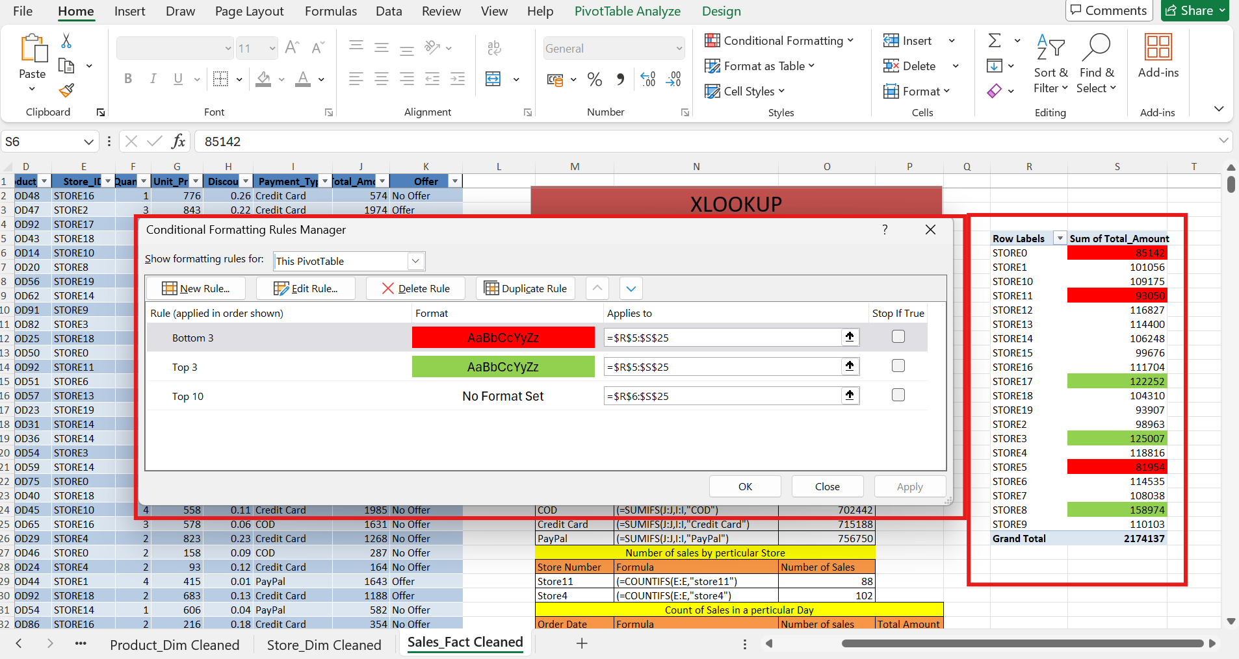

- Created a Sheet with all the Charts to form a dashboard
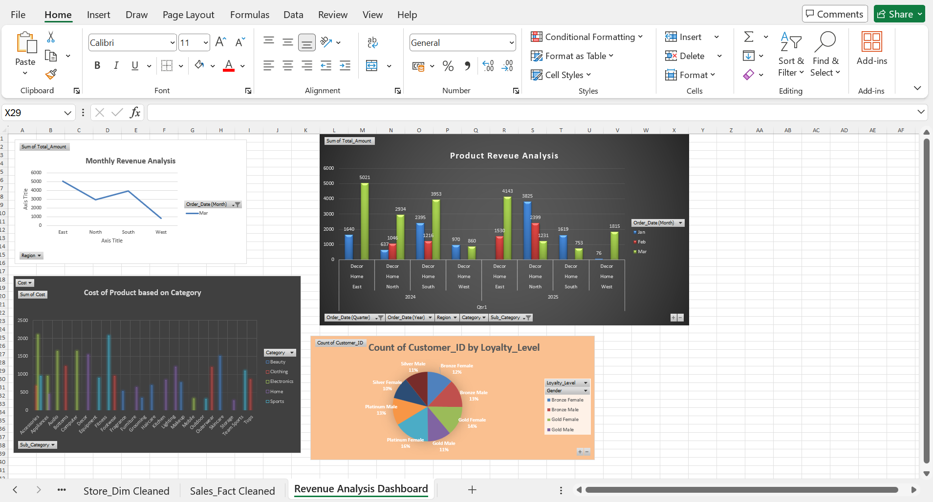

Key Findings from the Workbook
Total revenue recorded in the cleaned sales data is approximately $2,174,137 across 2,000 transactions.
The sales data covers the period from 14-Oct-2023 through 13-Oct-2025.
The workbook contains 20 stores and 100 products for analysis.
The cleaned customer table contains 496 customer records.
Platinum loyalty customers form the largest loyalty group in the prepared customer analysis.
PayPal generated the highest revenue among the three payment methods, followed by Credit Card and COD.
12 products were flagged for restocking because their stock level was 100 units or below; 88 products did not require restocking.
Among the stores, STORE8 has the highest total recorded revenue, while STORE5 has the lowest total recorded revenue in the full transaction period.
Metric | Result
Total Revenue | $2,174,137
Total Sales Transactions | 2,000
Stores | 20
Products | 100
Customers in Cleaned Table | 496
Products Requiring Restock | 12
Products Not Requiring Restock | 88
Highest Revenue Payment Type | PayPal — $756,434
Lowest Revenue Payment Type | COD — $703,130
Highest Revenue Store | STORE8 — $158,974
Lowest Revenue Store | STORE5 — $81,954

Skills Demonstrated
Excel data cleaning and preparation
Working with Excel Tables
Handling missing and inconsistent dat
Using IF, SUM, SUMIFS, COUNTIF and COUNTIFS
Creating PivotTables
Grouping and summarizing data by month
Building a simple relational data model
Analyzing business performance using revenue and sales measures
Creating inventory/restock indicators
Translating raw data into business-oriented insights

